Sample Internal (At Achieved Level)
Teachers note… pulling this together from all the different sections can be a very valuable teaching tool, which is why this is not included in the booklet.

Car Weights and Efficiency
Problem
I am looking at buying a car and I have heard that heavy cars use more petrol. Therefore I wonder if there is a relationship between the weight of a car and the car’s fuel efficiency for the purpose of predicting the fuel efficiency. | Question and Purpose linked to context, reason for investigation given.
Plan
The independent variable is the weight of the car, which is the mass of the car in kilograms. The dependent variable is the fuel efficiency in cities and on motorways, measured in kilometres per litre. | Variables Identified
The data used in this investigation is from new vehicles sold in America in 1993. | Source Named
Data
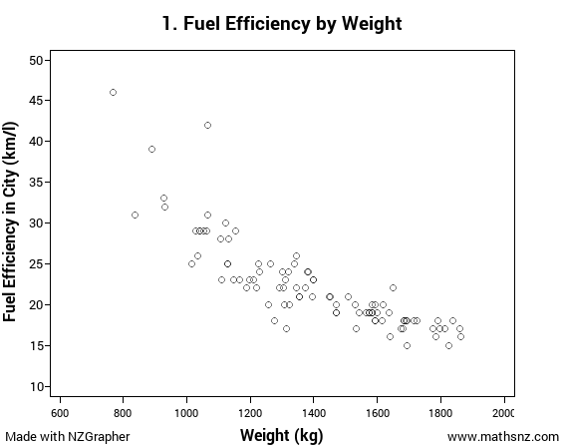 | Graph without Regression Line Given
Analysis
From the graph I can see a strong negative linear relationship between the weight of a car and the fuel efficiency of the car. | Trend
I can see that the association is negative because as the weight of the car increases, the fuel efficiency of the car decreases. | Association
The relationship is strong and linear as I can see most the points form a consistent pattern. | Relationship
The scatter appears to be reasonably consistent for car weights above about 1000 kg but below this there does appear to be fewer cars, probably due to not many small cars being manufactured. | Scatter
There are two cars that have higher fuel efficiency rates than expected. The first is a Geo Metro with a weight of 769 kg and a fuel efficiency of 46 km/l in the city. The second is a Honda Civic with a weight of 1066 kg and a fuel efficiency of 42 km/l. Both of these cars have very small engines so I expect this will have increased their fuel efficiency. | Outliers
Looking at the graph I cannot see any obvious groupings. This is what I would expect as there are not really two different sizes of cars, they are all on a continuous range. | Grouping
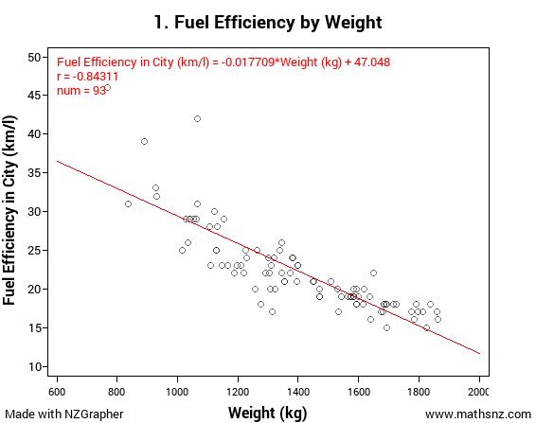 | Graph with Regression line given
The regression line of Fuel Efficiency = -0.017709 × Weight + 47.048 means that for every one kilogram increase in the car’s weight, the fuel efficiency decreases by 0.017709 kilometres per litre on average. | Interpretation of Regression Line
The fact this is a strong relationship is confirmed by the correlation coefficient of -0.8431, indicating that the linear relationship is quite strong as r is between -0.8 and -1. | Interpretation or r value
-0.017709 × 1200 + 47.048 = 26.7972  Based on my regression line I would predict that a car that weighs 1200 kg would have a fuel efficiency of approximately 27 mpg. I am / am not confident in this prediction because...  -0.017709 × 1600 + 47.048 = 18.7136  Based on my regression line I would predict that a car that weighs 1600 kg would have a fuel efficiency of approximately 19 mpg. I am / am not confident in this prediction because... | Predictions
Conclusion
In conclusion I think there is a strong negative relationship between the weight of cars and the fuel efficiency – the heaver the car, the more fuel it will use, therefore if we know the weight of a car we should be able to predict the fuel efficiency. This is useful for me to know because if I want a car that will use less petrol I know I should buy a lighter car. | Summarise and link back to the purpose

http://www.theaa.com/motoring_advice/car-buyers-guide/cbg_emissions.html

